# Dalhousie ATMega 644A Board Quick Reference

**Microcontroller: Atmel ATMega644A**

**Clock Frequency: 14.7456 MHz**

**Background on the Parts**

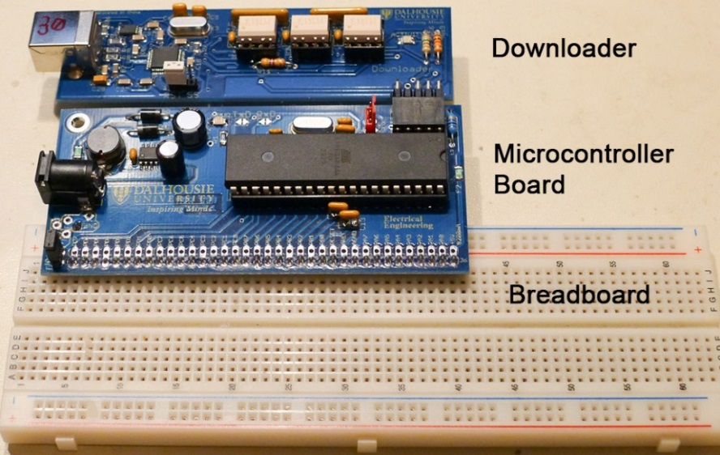

**Plugging Board into Breadboard**

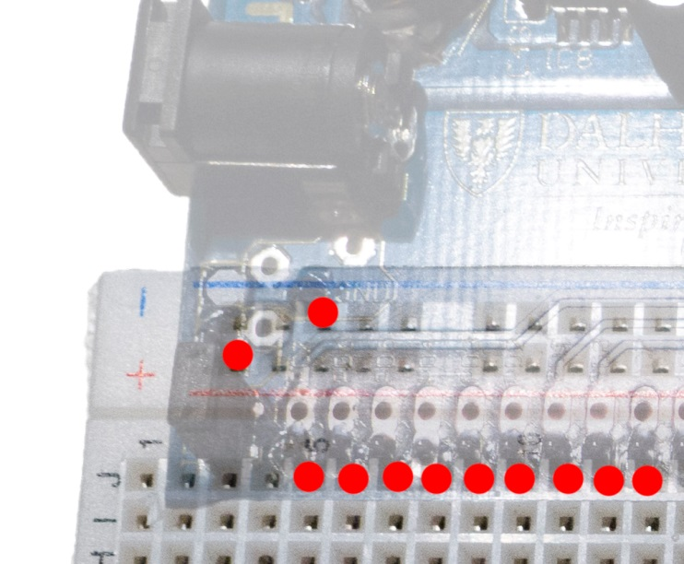

Carefully align board when plugging in, see above image for details.

**WARNING: The power supply rail comes from the input voltage jack, and will be ~10V! You can remove the jumper to the left of the DC input jack to stop this from happening.**

**Powering the Board**

Board is powered from 8-15V via the power jack. To use this assemble a power cable:

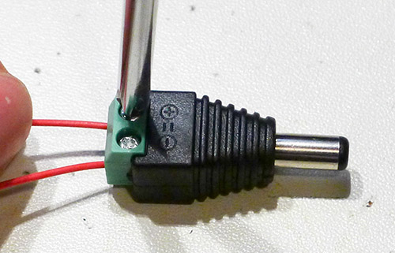

Note the + and – markings on this adapter are *WRONG*. If you connect the voltage backwards no harm is done – the board is protected from this, so simply reverse the connections if you accidently do this wrong.

**WARNING: The +V RAIL ON THE BREADBOARD COMES FROM THIS JACK, SO IS AROUND +8V. IT IS NOT 5V AS YOU MIGHT EXPECT. THERE IS A SEPARATE +5V OUTPUT PIN ON THE BOARD. YOU CAN REMOVE THE JUMPER NEAR THE DC INPUT JACK TO STOP THE RAIL FROM BEING POWERED.**

**Jumper Settings**

If you want code to automatically execute when downloading is done, set the jumper on the ‘Downloader’ portion to the ‘SS’ setting (right side of two pins). The jumper on the microcontroller board should always be in the ‘RST’ position – this is the default when you received it, so do not adjust!

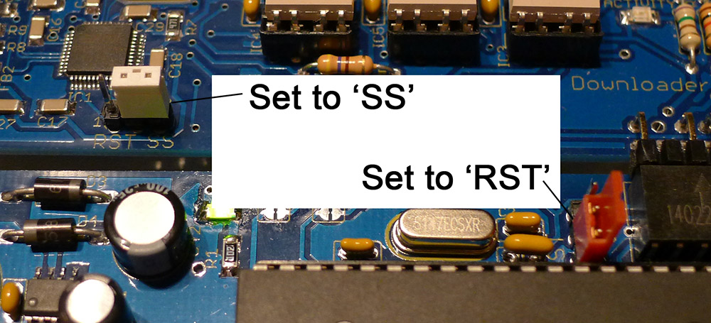

When controlling hardware with the board (such as a robot) **DO NOT** set the jumper to automatically execute code. Otherwise your robot may come to life accidently, instead keep the processor in reset until you unplug the downloading and are in full control.